1.volume of cone:-  
#include<iostream>  
#include<math.h>  
using namespace std;  
class volume  
{  
float x,radius,h;  
public:  
int getdata();  
int display();  
};  
int volume::getdata()  
{  
cout<<"enter the radius";  
cin>>radius;  
cout<<"enter the height";  
cin>>h;  
return 0;  
}  
int volume::display()  
{  
x=0.33*3.14*radius*radius*h;  
cout<<"volume of the cone is "<<x;  
return 0;  
}  
int main()  
{  
volume v;  
v.getdata();  
v.display();

}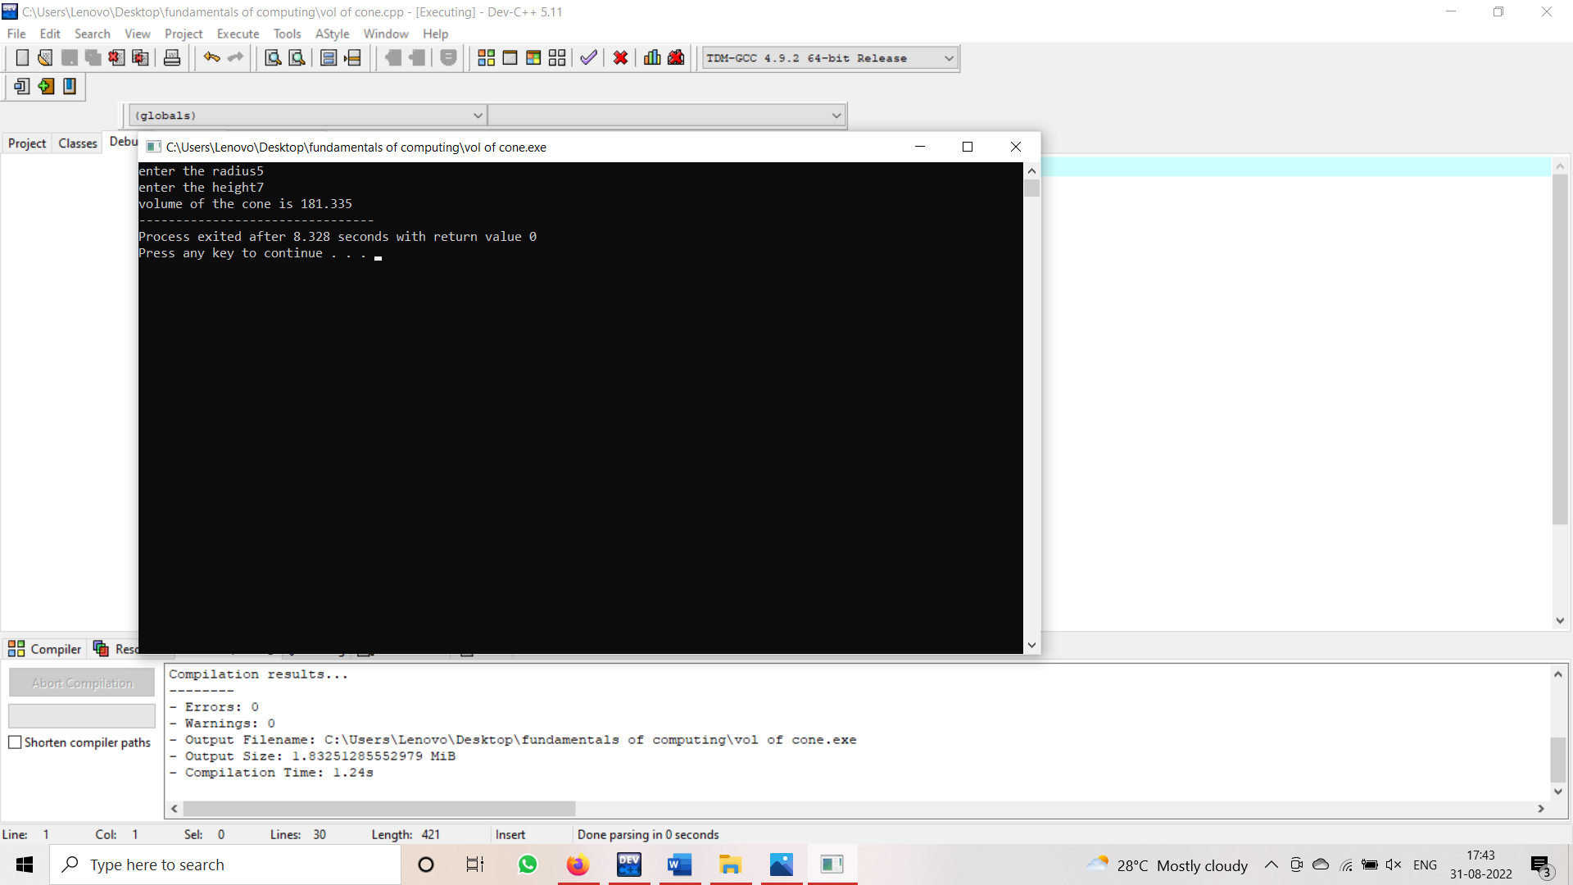

2.simple and compound interest:-  
#include<iostream>  
#include<math.h>  
using namespace std;  
class interst  
{  
int p,n,r;  
public:  
int getdata();  
int display();  
};  
int interst::getdata()  
{  
cout<<"enter the amount";  
cin>>p;

cout<<"enter the no.of years";  
cin>>n;  
cout<<"enter the rate of interst";  
cin>>r;  
}  
int interst::display()  
{  
cout<<"simple interst is "<<p*n*r/100;  
cout<<"compound interst is "<<p*(1+r/100,n);  
}  
int main()  
{  
interst i;  
i.getdata();  
i.display();  
}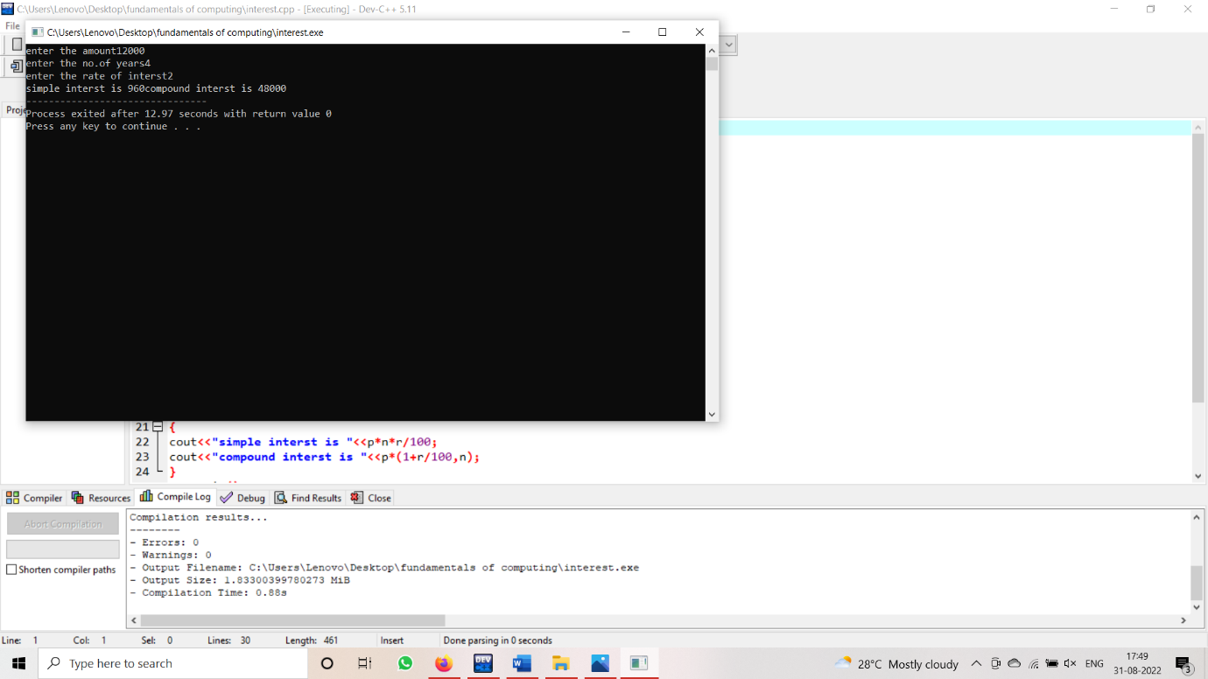

3.biggest among three

#include<iostream>

using namespace std;

int main()

{

int x,y,z;

cout<<"enter the 3 numbers";

cin>>x>>y>>z;

if(int(x)&&int(y)&&int(z))

{

if(x>y&&x>z)

{

cout<<"x is biggest";

}

else if(y>x&&y>z)

{

cout<<"y is biggest";

}

else

{

cout<<"z is biggest";

}

}

else

{

cout<<"invalid";

}

return 0;

}

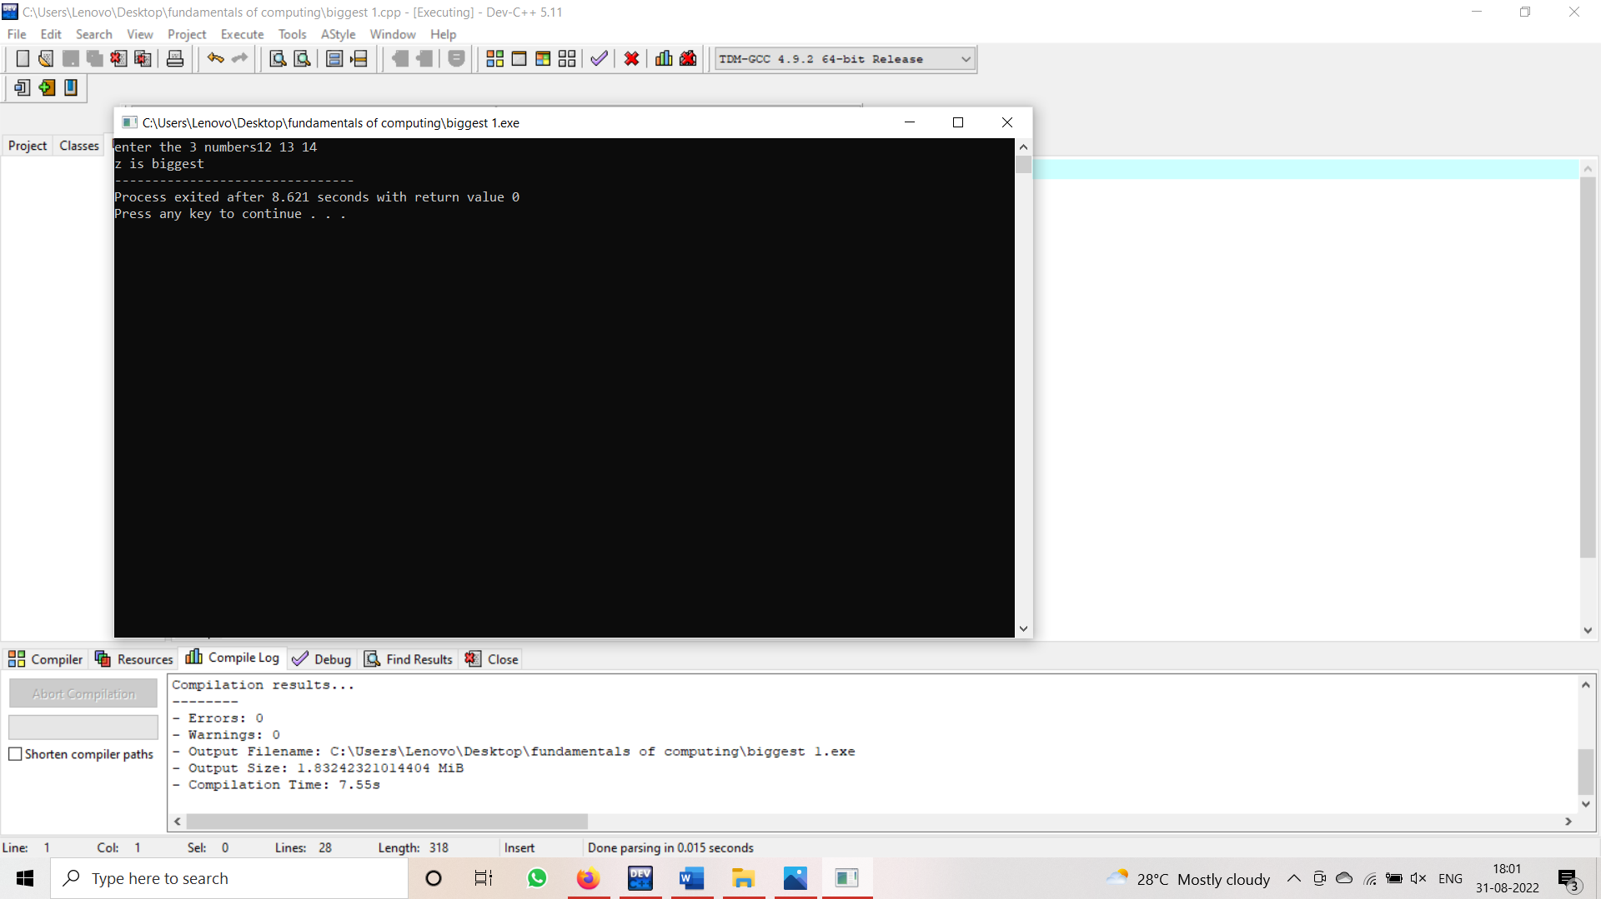

4.biggest among three using class and object:-  
#include<iostream>  
#include<math.h>  
using namespace std;  
class biggest  
{  
int x,y,z;  
public:  
int getdata();  
int display();  
};  
int biggest::getdata()  
{  
cout<<"enter the x";  
cin>>x;  
cout<<"enter the y";  
cin>>y;  
cout<<"enter the z";

cin>>z;  
return 0;  
}  
int biggest::display()  
{  
if(x>y&&x>z)  
{  
cout<<"x is greatest";  
}  
else if(y>x&&y>z)  
{  
cout<<"y is greatest";  
}  
else  
{  
cout<<"z is greatest";  
}  
return 0;  
}  
int main()  
{  
biggest b;  
b.getdata();  
b.display();

}

5.marks of student:-

#include<iostream>

using namespace std;

int main()

{

int m1,m2,m3,total,avg,reg_no;

cout<<"enter the reg no";

cin>>reg_no;

cout<<"enter the 3 marks";

cin>>m1>>m2>>m3;

total=m1+m2+m3;

avg=total/3;

if(int(m1)&&int(m2)&&int(m3)&&m1<=100&&m2<=100&&m3<=100)

{

if(avg>=90)

{

cout<<reg_no<<" grade A";

}

else if(avg>=80&&avg<=90)

{

cout<<reg_no<<" grade B";

}

else if(avg>=70&&avg<=80)

{

cout<<reg_no<<" grade C";

}

else if(avg>=60&&avg<=70)

{

cout<<reg_no<<" grade D";

}

else if(avg>=50&&avg<=60)

{

cout<<reg_no<<" grade E";

}

else

{

cout<<reg_no<<" fail";

}

}

else

{

cout<<"enter the valid marks";

}

return 0;

}

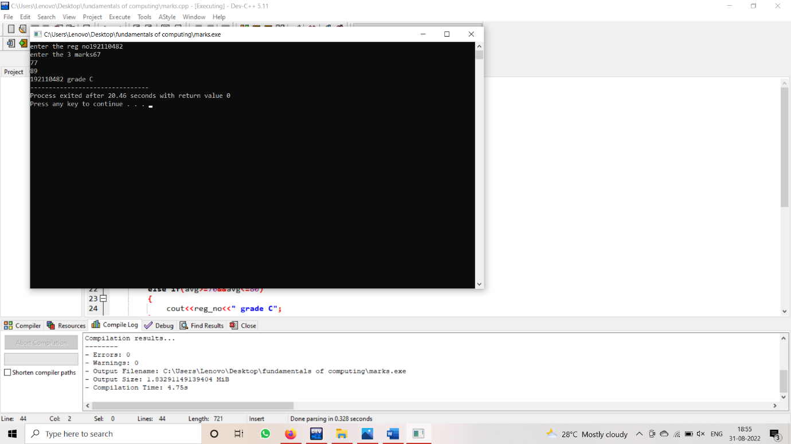

6.area of rectangle:-

#include<iostream>

#include<math.h>

using namespace std;

class rectangle

{

private:

int r;

public:

rectangle(int l,int b)

{

r=l*b;

}

int display()

{

cout<<"area of rectangle is "<<r;

}

};

int main()

{

int l,b;

cout<<"enter the length";

cin>>l;

cout<<"enter the breadth";

cin>>b;

rectangle r(l,b);

r.display();

return 0;

}

